Phase 1: Preparation & Prerequisites
Before installing, ensure your host computer (Windows, macOS, or Linux) has: [1, 2, 3]
- CPU: Minimum 4 cores with virtualization enabled (Intel VT-x or AMD-V in BIOS).
- RAM: At least 16 GB (8 GB minimum, but performance will be slow).
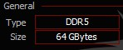
- Storage: 60 GB to 100 GB of free Solid State Drive (SSD) space. [1, 2, 3]
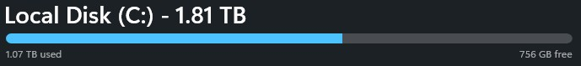
Phase 2: Hypervisor Installation
A hypervisor allows you to run multiple operating systems simultaneously on your computer. [1]
- Go to the official VirtualBox website.
- Download the installer matching your host operating system.
- Download the VirtualBox Extension Pack from the same page.
- Run the installer and accept all default settings.
- Open VirtualBox, go to Tools > Extension Pack, and install the extension pack. [1, 2, 3, 4]
Phase 3: Downloading OS Images [1]
Never download operating systems from third-party sites. Use official sources:
- Kali Linux: Go to the Kali Linux download page. Choose Virtual Machines and select the VirtualBox pre-built image (.7z or .ova file). This saves installation time.
- Ubuntu Linux: Go to the Ubuntu Desktop download page. Download the latest LTS (Long Term Support) ISO image. [1, 2, 3, 4, 5]
Phase 4: Setting Up the Virtual Machines [1]
You will configure two machines: Kali Linux (the attacker/analyzer) and Ubuntu (the target/user). [1, 2, 3]
Creating the Ubuntu VM [1]
- Click New in VirtualBox.
- Name it Ubuntu-Target and select your downloaded Ubuntu ISO.
- Allocate at least 2 vCPUs and 4 GB RAM.
- Create a virtual hard disk with at least 25 GB of space.
- Follow the standard on-screen Ubuntu installation prompts. [1, 2, 3, 4, 5]
Importing the Kali Linux VM [1, 2]
- Extract the downloaded Kali .7z file (if using the pre-built image).
- In VirtualBox, click File > Import Appliance or double-click the .vbox file inside the extracted folder.
- Keep the default configurations (usually 2 vCPUs and 2 GB RAM). [1, 2, 3, 4, 5]
Phase 5: Lab Networking (Crucial Step)
To safely analyze traffic without exposing your main home network, isolate your lab. [1]
- In VirtualBox, go to File > Tools > Network Manager (or Network tab).
- Create a NAT Network (name it LabNetwork). Enable DHCP.
- Go to the Settings for both the Ubuntu and Kali VMs.
- Select Network > Adapter 1.
- Change "Attached to" from NAT to NAT Network.
- Select LabNetwork from the dropdown. [1, 2, 3, 4, 5]
Both machines can now talk to each other and access the internet safely, but outside devices cannot attack them. [1]

Learning Exercises
Exercise 1: Linux Commands [1]
Boot both machines, open the Terminal application, and practice these commands: [1, 2, 3]
- pwd: Shows your current folder path.
- ls -la: Lists all files, including hidden ones, with details.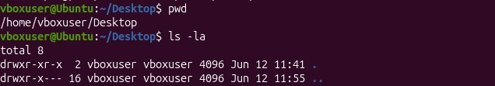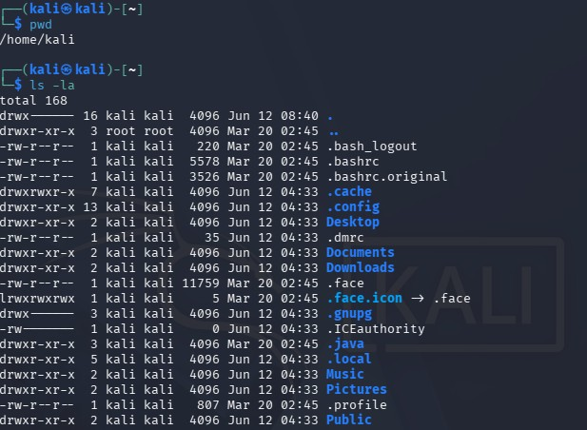
- cd [folder]: Moves you into a different folder.
- sudo apt update && sudo apt upgrade: Refreshes your system software.
- ifconfig or ip a: Displays your current internal IP address.
- ping -c 4 [IP_Address]: Tests connectivity by sending packets to the other VM. [1, 2, 3, 4, 5]
Exercise 2: Networking Concepts [1]
- On your Kali machine, find its IP address using ip a.
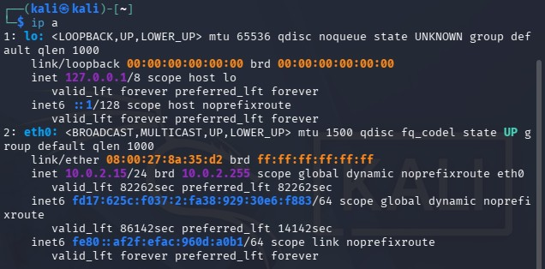
- On your Ubuntu machine, find its IP address using ip a. 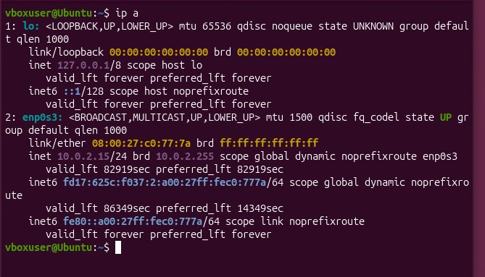
- Verify they are on the same subnet (e.g., both should start with 10.0.2.x or similar).
Kali 10.0.2.15 / Ubuntu 10.0.2.15
- Use ping [Ubuntu_IP] from Kali to confirm they can communicate. [1, 2, 3]
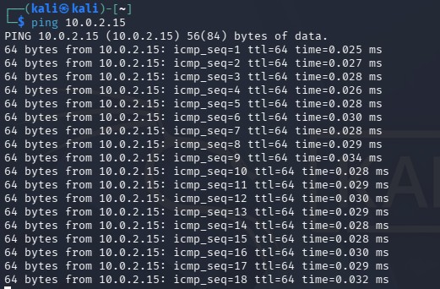
Exercise 3: Wireshark Packet Analysis [1]
Wireshark captures and decodes data passing through your network card. [1, 2]
- Open Wireshark on your Kali Linux machine (you may need to run sudo wireshark in the terminal).
- Select your active network interface (usually eth0 or enp0s3) and click the blue shark fin to start capturing.
- Open your Ubuntu machine, open a terminal, and run a ping to Kali: ping -c 4 [Kali_IP].
- Go back to Kali, and click the red square button to stop the Wireshark capture. 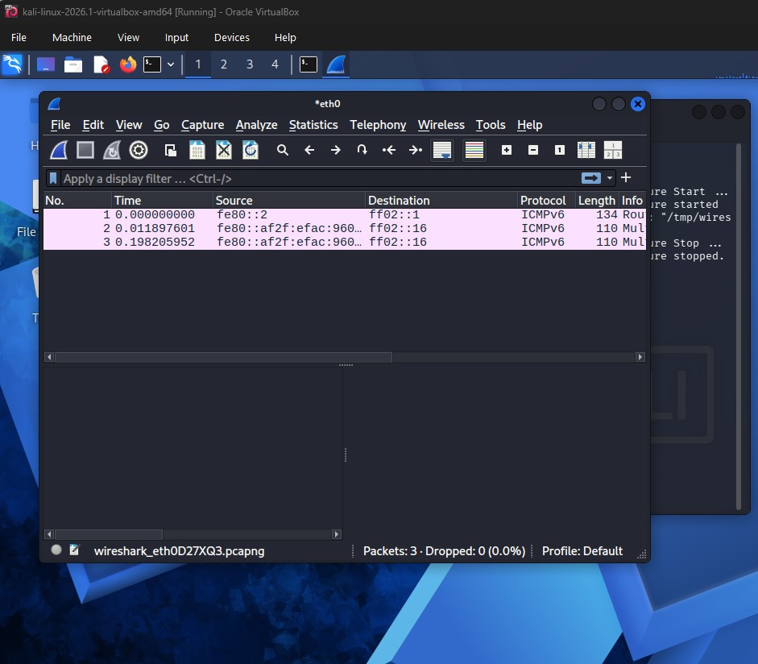
- In the top filter bar of Wireshark, type icmp and press Enter.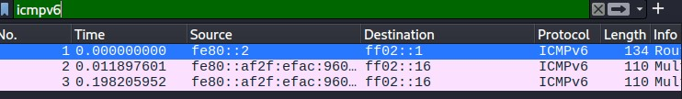
- Look at the captured lines. You will see the Echo (ping) request sent by Ubuntu and the Echo (ping) reply sent back by Kali.
- Click on a packet to view the layers: Ethernet (Layer 2), IP (Layer 3), and ICMP (Layer 4). [1, 2, 3, 4, 5]

